Dr Gerwyn Mahoney-Davies,
Clinical Psychologist
www.gmdpsychology.com
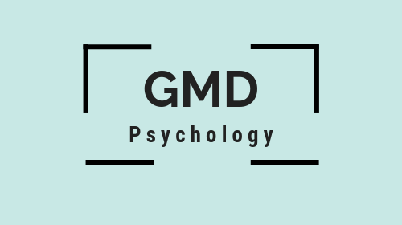

Terms and Conditions for Psychological Therapy

Session information

Update 2020: Due to COVID-19 all sessions are currently taking place virtually.

For adults, sessions will generally be one to one and confidential (although see the limits of confidentiality below).

For older children, most sessions are likely to be one to one, but parents will be involved during the initial appointment and throughout our work together when relevant. Parents are welcome to ask questions about therapy but will be asked to respect their children’s right to confidentiality also.

For younger children it is likely parents will be more involved throughout. This is all flexible according to needs.

Confidentiality (and its limits)

All private information exchanged is kept confidential, meaning that it will not be shared without consent. However, I am bound by regulations to break confidentiality in situations involving risk. So, if I am concerned about your or someone else’s safety I will be required to inform someone who is able to keep you or others safe. In most instances I will tell you that I am going to do this, although if I am made to believe that telling you would increase the risk I will take relevant action to maintain safety. This may include a telephone conversation with your emergency contact, GP (if emergency contact is unavailable) or other relevant agency. In the case of children, if a safeguarding issue is disclosed then relevant action will need to be taken, possibly including passing this information to children’s services.

In order to ensure psychologists are offering the most appropriate support, they receive clinical supervision from another psychologist regularly. It is likely all cases are discussed during supervision but confidentiality will be maintained by ensuring anonymity. The supervising psychologist is also bound by the same confidentiality regulations and will not discuss any aspects of what they have heard outside of supervision sessions.

I am responsible for keeping your data private. For full information please see my privacy policy which is available on my website www.gmdpsychology.com

Crisis and immediate help

I am not able to provide crisis support and if you are concerned about significant needs or distress and need immediate or urgent support you should go to your GP or A&E.

Fees

Psychological therapy assessment session: £120
Psychological therapy subsequent sessions: £100

Payment of Fees

Payment is normally made at the end of each session by cash, cheque, card or bank transfer (in which case payments need to be received within 7 days of the session). Payments can also be made in advance for a set number of sessions, unless you hold Private Medical Insurance (see below).

BACS payment details are:
sort code 30-67-34
account 79977963
Name Gerwyn Mahoney-Davies

Private Medical Insurance

If you hold Private Medical Insurance (PMI), please check the reimbursement level that will be available to you from your relevant provider for the therapy. If your PMI reimbursement does not cover the fee in full, you must pay the difference between the fee and the PMI reimbursement.

If you have not already done so, please inform us of your PMI's Authorisation Code and of the limits to the funding available.

PMI invoices are raised monthly in arrears. Payment is due 14 days from the date of the invoice. Please promptly forward the invoice to your PMI provider in order for them to process payment.

Cancellation policy

If you are unable to attend your appointment please let us know as soon as possible. 48 hours notice is required for cancellation. Where there is less notice, or you do not attend your appointment, a £50 fee will occur.

The therapist will endeavour to give you as much advance notice as possible in terms of holidays or of any need to cancel a future appointment.

